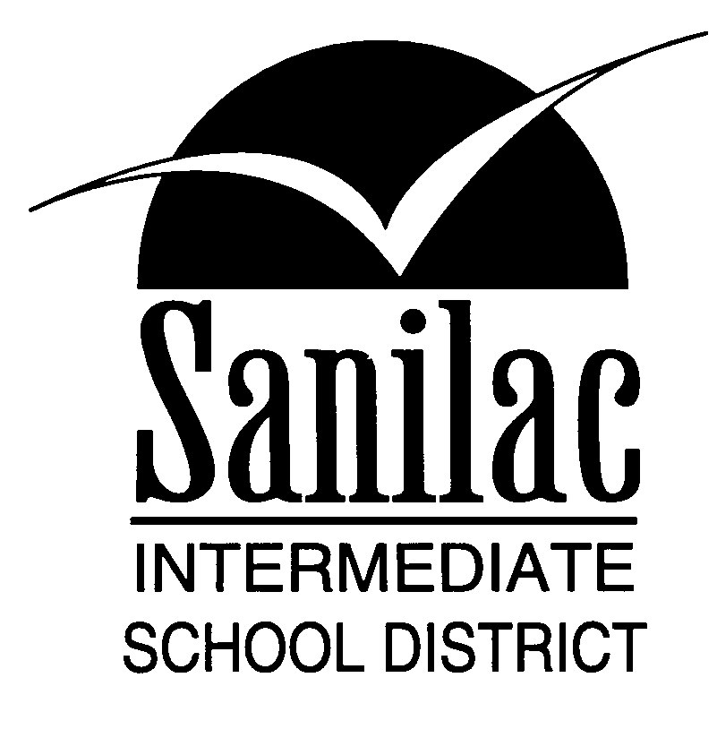
Special Education Services
46 North Jackson Street
Sandusky, Michigan 48471
810-648-2200

AGE OF MAJORITY NOTICE TO PARENTS/GUARDIAN(S)

Name: ________________________________ Date: ______________________
Address: ______________________________ Student: ___________________
City/St/Zip: _____________________________ Birth Date: _________________

Dear: __________________________________
Your (son/daughter) has notified the school that he or she has reached the Age of Majority. As you know, according to provisions of federal and state law, persons of age eighteen or more years now hold legal adult status.
Since some of these young adults are still students in the public schools, it becomes necessary for schools to recognize and deal with them somewhat differently than other minor students. An adult student is personally accountable for his/her actions. Such a student may communicate and act directly with the school concerning school matters without involvement of other persons, if he/she so desires.
Public information will continue to be provided to parents of adult students concerning students, schools, and school related activities.

STUDENT STATEMENT:

I elect to have all reports and communications regarding my program and performance directed to:

Myself
My parents or former legal guardian
Student Signature: ____________________________________

Please call the Sanilac Intermediate School District Special Education office at (810) 648-9020, ext. 403 if you have any questions regarding this matter.

Respectfully,

___________________________________________
School Official (Principal)

Copies: _____ Student File
_____ Home School

